Cyber Chip Level II Internet Safety Pledge (Grades 6-8)
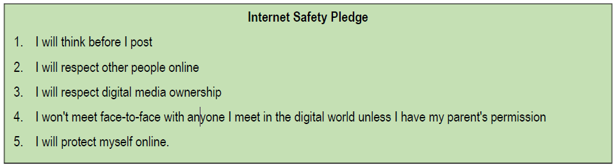

Scout Signature: ________________________________________ Date: ____________________

Scout Name (Printed) _____________________________________

Write and sign a personalized contract with your parent or guardian that outlines rules for using the computer and mobile devices, including what you can download, what you can post, and consequences for inappropriate use.
General Comments:
____________________________________________________________________________________________________________________________________________________________________________________________________________________________________________________________________________________________________________________________________________________________________________________________
What I can download:
________________________________________________________________________________________________________________________________________________________________________________________________________________________________________________________________________________________________________________What I can Post:
____________________________________________________________________________________________________________________________________________________________________________________________________________________________________________________________________________________________________________________________________________________________________________________________
Consequences for inappropriate use:
____________________________________________________________________________________________________________________________________________________________________________________________________________________________________________________________________________________________________________________________________________________________________________________________
Scout signature: ________________________________________ Date: __________________________
Parent(s) signature: _____________________________________ Date: __________________________

